#### Regression Models Course Project of Motor Trend

#### Relationship between MPG and transmissions

JackHo | 4 June 2017

#### Executive summary

The target of this analysis lies on finding the relationship between a set of variables and miles per gallon (MPG) and the company is particularly interested in **“Is an automatic or manual transmissions better for MPG”** and **"Quantify the MPG difference between automatic and manual transmissionss"**, I will firstly refine the data with only keeping the am and mpg variables, then try to add more predictors into the model to improve it. In the end, I got a model: $mpg=12.0638×am-3.5641×wt+0.9835×qesc-3.5799×am×wt+12.4791$ which r.square value is equal to 90.4% data and is overall significant (p.value = 7.335181e-13).

#### 1. Data Preparation

Load essential packages.

library(MASS);library(car);library(dplyr);library(ggplot2);library(knitr);library(broom);mt_cars <- mt_cars %>% dplyr:: select(mpg,am)

#### 2. Data Sleuthing

The variable am is a binary variable, which represents the status of the transmissions (0 = automatic, 1 = manual) of every cars. While the mpg variable means the miles/galon (US). With tapply(X = mt_cars$mpg,INDEX = mt_cars$am,length), there are 13 cars have the manual transmissions and 19 cars have the automatic one.

**It can be concluded that automatic cars are more petrol-efficient than manual cars**. With tapply(X = mt_cars$mpg,INDEX = mt_cars$am,summary), *for those cars have the automatic transmissions (am = 0), the min(mpg) is 10.40/galon (US), the max(mpg) is 24.40/galon (US) and the mean(mpg) is 17.15/galon (US). While, the values of mpg of cars with manual transmissions (am = 1) are larger than those of mpg of automatic cars. (Such comparison can also be perceived from the Appendix 1)*.

#### 3. Build the Linear Model

Firstly, let's build a one-variable linear model, where mpg is a the outcome and the am is independent variable.

mt_cars$am <- as.factor(mt_cars$am)  
model <- lm(data = mt_cars, mpg~ am)

From the model, we could basically get the formul: $mpg=7.244939×am+17.147368,$ which means the manual cars cost more *7.244949*/galon (US) in average of mpg than automatic cars do. The p.value is *0.0002850207* shows that the model is credible. However, from the value of the r.squared and its adjusted value (*0.3597989* and *0.3384589*), the model can only explain about 35% of dependent data. Thus, I decide to add more variables in order to improve the model.

#### 4. Improve the model and Diagnose It

Next, after adding more predictors into the model, the results show that the overall model is significant (3.793152e-07) and the r-squared value is high (87%), but many independent variables are non-significant and I guess this might be because of the multicollinearity problem.

mt_cars <- datasets::mtcars  
mt_cars$am <- as.factor(mt_cars$am)  
model <- lm(data = mt_cars,mpg~.)

Then, to figure out whether I add in some real-unnecessary variables, I decide to apply the stepAIC() function to help me filter the useful variables.

model1 <- stepAIC(object = model, direction = "both")

Now, based on the new model, I get a new formula: $mpg=-3.916504×wt+1.225886×qsec+2.935837×am+9.617781,$ which means with the wt and qsec remained, manual cars cost more *2.935837*/galon (US) in average of mpg than automatic cars do. Meanwhile, the new model shows the coefficients of variables are significant, explains about 85% original data and it is a significant model (p.value = *1.210446e^-11*).

Although the statics show that the new model is quite good, there are some essential diagnostics should be processed in order to make sure the model is really creidble.

* Outliers: (Refer to the Appendix 2)

outlierTest(model1)  
## rstudent unadjusted p-value Bonferonni p  
## Chrysler Imperial 2.323119 0.027949 0.89437

hatvalues(model1)[order(hatvalues(model1),decreasing = T)] %>% head(4)

## Merc 230 Lincoln Continental Chrysler Imperial Cadillac Fleetwood   
## 0.2970422 0.2642151 0.2296338 0.2270069

With the outlierTest(), the car "Chrysler Imperial" has been identified as an outlier, and with the hatvalues() "Chrysler Imperial" is also in the influence list. Thus, looks the record "Chrysler Imperial" should be excluded.

new_model <- lm(data= mt_cars[-which(row.names(mt_cars) == "Chrysler Imperial"),], mpg~.) %>% stepAIC()

In model without "Chrysler Imperial", the model is more significant and can explain more data. However, the variable am is not significant anymore. Let's see whether it should be excluded.

anova(update(new_model,.~.-am),new_model)  
## Model 1: mpg ~ wt + qsec  
## Model 2: mpg ~ wt + qsec + am  
## Res.Df RSS Df Sum of Sq F Pr(>F)  
## 1 28 154.94   
## 2 27 141.09 1 13.858 2.6521 0.115

summary(update(new_model,.~.-am))$r.squared - summary(new_model)$r.squared

## [1] -0.01264364

Although the anova() tell us that even the am is excluded, the model will not be affected a lot, to keep a higher r.squared value, I decide not to delete it.

To improve the model, I try to interact the am, wt and qsec.

model_int <- update(new_model,.~.+ am:wt + am:qsec) %>% stepAIC()

anova(new_model,model_int)  
## Model 1: mpg ~ wt + qsec + am  
## Model 2: mpg ~ wt + qsec + am + wt:am  
## Res.Df RSS Df Sum of Sq F Pr(>F)   
## 1 27 141.09   
## 2 26 105.04 1 36.046 8.9224 0.006073 **

model_int %>% summary() %>% glance()

## r.squared adj.r.squared sigma statistic p.value df  
## 1 0.9041659 0.8894222 2.009966 61.32557 7.335181e-13 5

**Finally, the model could explain *90.4%* data and is overall significant (p.value = *7.335181e-13*).**

* Multicollinearity:

Owning to the help of stepAIC(), I exclude several of vairables at the beginning, now let's check whether the model_int got that issue:

sqrt(vif(model_int))>2

## wt qsec am wt:am   
## FALSE FALSE TRUE TRUE

tmp <- mtcars %>% dplyr::select(wt,am,qsec) %>% mutate(wt_am = wt*am)  
kappa(cor(tmp))

## [1] 110.0319

vif() shows the model has certain multicollinearity issue, but calculating the kappa() shows that the model does not have to many issues on severe multicollinearity--- the kappa value is 110, which represents very slight multicollinearity (kappa_value < 100: no multicollinearity; 100 < kappa_value < 1000: a fair multicollinearity, but can be kept; kappa_value > 1000: must be handled).

**Thus, the final model does not have strong multicollinearity issue and all the current predictors will be kept**.

* Heteroskedasticity: (Refer to the Appendix 2)

**The dots in the graph "Check the Heteroskedasticity" have no particular pattern, which means this model does not have non-linear relationships and no heteroskedasticity**.

* Normality: (Refer to the Appendix 2)

**The plot "Check the normality of the new model" shows the residuals are basically normally distributed because most of dots are are within the dashed red intervals, indicating that the residuals follow a normal distribution**.

#### 5. Summary

The mpg can be explained by am, wt and qesc, and their relationship can be denoted as: $mpg=12.0638×am-3.5641×wt+0.9835×qesc-3.5799×am×wt+12.4791$, which means when the wt and qesc remained, automatic cars will save more *8.4839* (12.0638-3.5799) /galon (US) petrol than manual cars.

#### Appendix

* Appendix 1

ggplot(data = mt_cars %>% mutate(am =factor(mt_cars$am,levels = c("0","1"),labels = c("automatic","manual"))), aes(x=mpg,fill=am)) + geom_histogram(bins = 8) + ggtitle(label = "Distribution of the MPG of Cars with Automatic and Manual transmissions") + theme_bw()

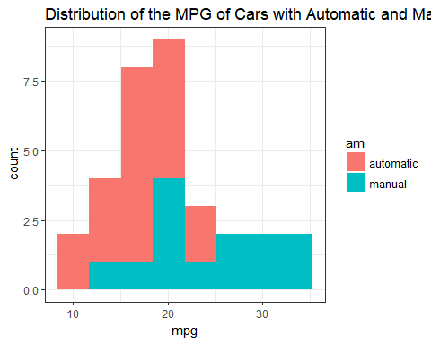-

* Appendix 2

par(mfrow=c(1,2))  
cutoff <- 4/((nrow(mtcars)-length(model1$coefficients)-2))   
plot(model1, which=c(4,5), cook.levels=cutoff)

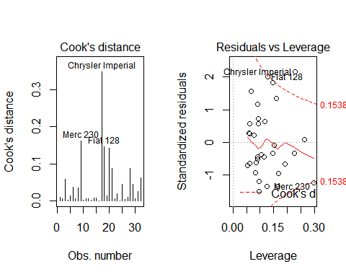

plot(model_int,which = 1)  
y.rst<-rstandard(model_int)  
y.fit<-predict(model_int)  
plot(y.fit~y.rst,main="Check the Heteroskedasticity")

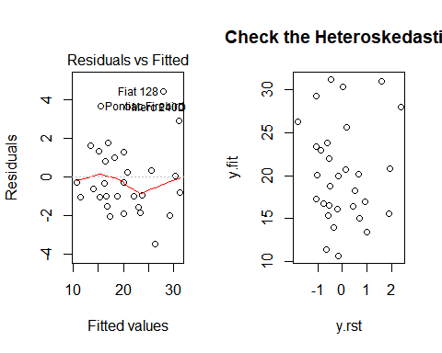

par(mfrow=c(1,1))  
qqPlot(model1, main = "Check the normality of the new model")

